

***Banking Opportunity for All***

[www.opportunityghana.com](http://www.opportunityghana.com)

Call Centre 0302-610001/0800-850850

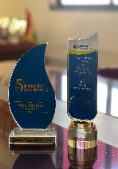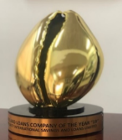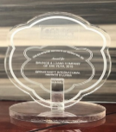

**MILESTONES**:

* The first to introduce micro insurance to cover loans.
* The only institution in Ghana to create a loan product for the physically challenged fraternity in 2013.
* The first to introduce Cinema Van for Financial Literacy Education in rural communities since 2013.
* The first to introduce mobile van Banking for remote client recruitments in Ghana.
* ISO/IEC 27001 Certified

Industry Data Security certified.

Stansdard certrified

**AWARDS**

**268,383 Customers** Customers are the centre of our business and are served with life-changing products such as loans, deposits, micro insurance, e-banking services and remittances. Transformational training, business advisory services, and capacity building are embedded in our client interactions.

**602 Human Capital**

Well trained employees who are highly dedicated and committed to living the values and achieving our mission

***Core Values***

***C****ommitment*

***H****umility*

***R****espect*

***I****ntegrity*

***S****tewardship*

***T****ransformation*

**\*717#**

**Opportunity Mobile**

* GHAMFIN- Best sustainable MFI in Agricultural Finance 2024, Best Disability Product 2024 & Special Recognition award to Mr. Kwame Owusu-Boateng, CEO of Opportunity International Savings and Loans Ltd.
* Chartered Institute of Credit Management (Ghana)- Savings and Loans Company of the year 2024.
* Chartered Institute of Marketing, Ghana (CIMG) – 2019 & 2020. Savings and Loans Company of the year
* Ghana Business Awards – 2018, 2019, 2020 & 2021

Savings and Loans Company of the year

* Ghana Accountancy & Finance Awards – 2018, 2019, 2021.

Savings and loans Company of the year

* Ghana Business Standard Awards – 2019, 2020, 2021.

***52 Awards since 2018:***

|  |  |  |
| --- | --- | --- |
| **Total Assets** | **GHS 603.7 M** | **$41.0 M** |
| **Loan Portfolio** | **GHS 308.8 M** | **$20.9 M** |
| **Deposit Balances** | **GHS  418.3 M** | **$28.4 M** |
|  |  |  |

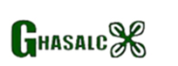

OISL Ghana



***© OISL – December 2024***

|  |  |
| --- | --- |
| **DELIVERY CHANNELS** | |
| Branches | **35** |
| Agencies | **3** |
| Mobile Money Merchants | **503** |
| ATMS | **20** |

**SOCIAL & COMMUNITY IMPACTS**

* Sustainability & Social Investments Awards – 2018, 2019, 2021 & 2022.
* Health, Environment, Safety and Security Awards – 2019.
* Ghana’s Top 50 Employers for Gender Equality and Rankings-2024